Morphology and Electrical Signal Sensitivity of Soft Porous Collagen – Hydroxyapatite Inkjet Printed Film Used for Bio Marker
John Goodman^{a,*}, Issarawadee Gobkham^{b}, Jiang Shun Li^{c}
ªDepartment of Radiology, University of Wisconsin - Madison, Madison, WI 53705, USA
^{b}School of Chemistry, Institute of Science, Suranaree University of Technology, Nakhon Ratchasima, 30000, THAILAND
^{c}Institute of Functional Nano & Soft Materials (FUNSOM), Collaborative Innovation Center of Suzhou Nano Science and Technology, Soochow University, Suzhou, Jiangsu 215123, China.
*Corresponding Author’s E-mail: jgoodman@u-wisconsin.edu
Abstract
Generally, both collagen and hydroxyapatite are the main components of the natural bone. Therefore, this study aimed to produce soft porous three-dimensional collagen-hydroxyapatite composite scaffolds by a freeze drying technique. The porous structure of the collagen-hydroxyapatite scaffolds have also been modified by adding vitamin E as a pore former with different concentrations. The lyophilized porous samples were stabilized using chemical cross-linking. Morphology, porosity and density, of materials have been studied by using SEM and micro-CT, respectively. Due to its high surface area, the electrical response properties and textural properties were tested under compressed twice at 25% IFD using a texture analyzer to monitor the behavior of the scaffolds when compressed. The behavior of the scaffolds were then reported and discussed in the term of young’s modulus, cohesion energy and springiness. The results revealed that all samples of the composite scaffolds showed a good electrical response characteristic and flexibility properties. The structure looked similar to sponges with fully irregular interconnected macro-pores. The morphology of the composite scaffolds consisted of the porous structure produced by ice crystals and structure of hydroxyapatite dispersed in collagen matrix. The higher the vitamin E content was added, the less the structure created by the collagen itself was observed particularly in sample with 15%vol Vitamin E. The Young’s modulus of the composite scaffolds ranged between 0.08-0.17 MPa. The Young’s modulus of the scaffolds decreased with increasing vitamin E contents. Similarly, the springiness or the ability of the scaffolds spring back after the first compression compared to the maximum deformation of scaffolds was reduced with increasing vitamin E content. However, the scaffolds with 15 vol% vitamin E obtained the superior the cohesion energy compared to the scaffolds without vitamin E. So that, this could be an alternative method to prepare economical high-sensitivity bio-marker film.

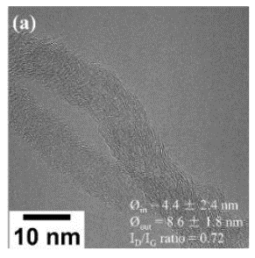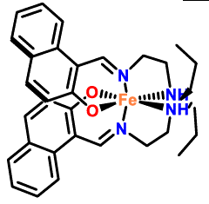

Fig.1 TEM image and molecular structure of composite film

Keywords: Inkjet printing, Collagen-Hydroxyapatite thin film, Electrical response, Bio marker, Vitamin sensitivity

